**ASSIGNMENT NO 1**

**Date:20/03/2021**

**Title:** **Installation, configuration & testing of Oracle 12c EE / 18c XE**

**Objective:**

1. Install Oracle Server on one machine.

2. Install Oracle Client on another machine.

3.Create new schema/user by your group-id e.g. 2018BCGRP28

4.Create sample tables in newly created schema / user

5.Create GUI desktop application in Python which will connect to

schema created in step 7. Allows to choose available tables.

Demonstrate the CRUD operations on selected table.

6.REPEAT ABOVE WORK FOR MySQL 8.0 DATABASE

**Introduction:**

For storing different types of data ,oracle database is mostly used and for this purpose and manipulation,retrieval of data it must be stored in particular set .database helps in this case .so by installing oracle database server and client ,taking input of data from user and its CRUD operations can be done easily .so in this assignment connection between client and server is established and the ouput is shown as screenshots.

**Theory:**

In the Oracle client/server architecture, the database application and the database are separated into two parts: a front-end or client portion, and a back-end or server portion. The client executes the database application that accesses database information and interacts with a user through the keyboard, screen, and pointing device such as a mouse. The server executes the Oracle software and handles the functions required for concurrent, shared data access to an Oracle database.

Although the client application and Oracle can be executed on the same computer, it may be more efficient and effective when the client portion(s) and server portion are executed by different computers connected via a network

**Distributed Processing**

*Distributed processing* is the use of more than one processor to divide the processing for an individual task. The following are examples of distributed processing in Oracle database systems:

* The client and server are located on different computers; these computers are connected via a network
* A single computer has more than one processor, and different processors separate the execution of the client application from Oracle .

DFD:

Procedure:

Oracle requires that you use the 64-bit Oracle database software.

To download and install the 64-bit Oracle database software:

1. Sign on to the Oracle support website:
2. <https://support.oracle.com/CSP/ui/flash.html>
3. Click the **Patches and Updates** link.

The Patch Search screen appears.

1. In the **Patch Name** or Number field, enter **17694377** and click **Search**.

The patchset list appears.

1. Select **Patch 17694377: 12.1.0.2.0 PATCH SET FOR ORACLE DATABASE SERVER** for the 64-bit version of your platform.
2. Click **Download**.The File Download screen appears.
3. After that extract the folder and run the application and install carefully
4. After that make user in oracle server and provide username and password accordingly
5. After that download the client instance on your machine and set up connection between them .
6. After that download python and using ant ide check if program creates table in database or not
7. After that create gui application.
8. Same procedure applies for mysql 8.0 version.

Results:

1.user formed

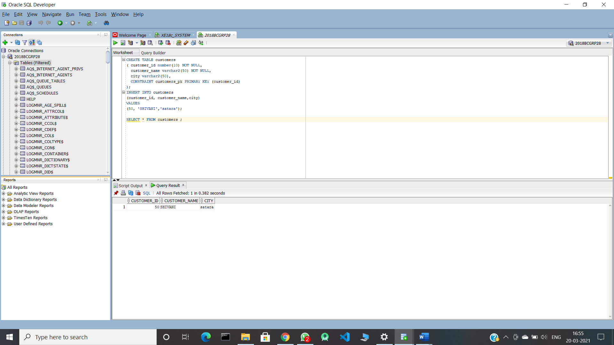

2.GUI FORMED:

Conclusion:

Using python we can connect client to server and perform number of queries on database.

.